MOTION FACTORY FILMS presents
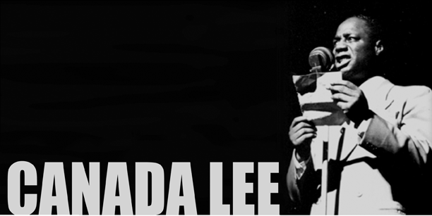

Man Out Front
by first-time documentary filmmaker, Kenneth Kilfara

“I’d rather dig a ditch for a living
than act some foolish parody.”
-Canada Lee

1: WHAT MAKES CANADA LEE UNIQUE? An untold number of people marched the long road to Civil Rights, shedding blood and tears in the fight for equality. In 1941, Canada Lee stood alone on a stage and captivated a nation. One-time boxer turned actor, Canada Lee broke barriers on Broadway and in Hollywood, working with the likes of Orson Welles, Alfred Hitchcock and Sydney Poitier. His is a story of firsts. The first black man: to be the draw on Broadway, ‘Come see CANADA LEE in Native Son’, to play a non-stereotyped character in Hollywood, to play a white character on Broadway, to produce on Broadway, and to be blacklisted during the ‘Hollywood 10’ scandal of 1947.

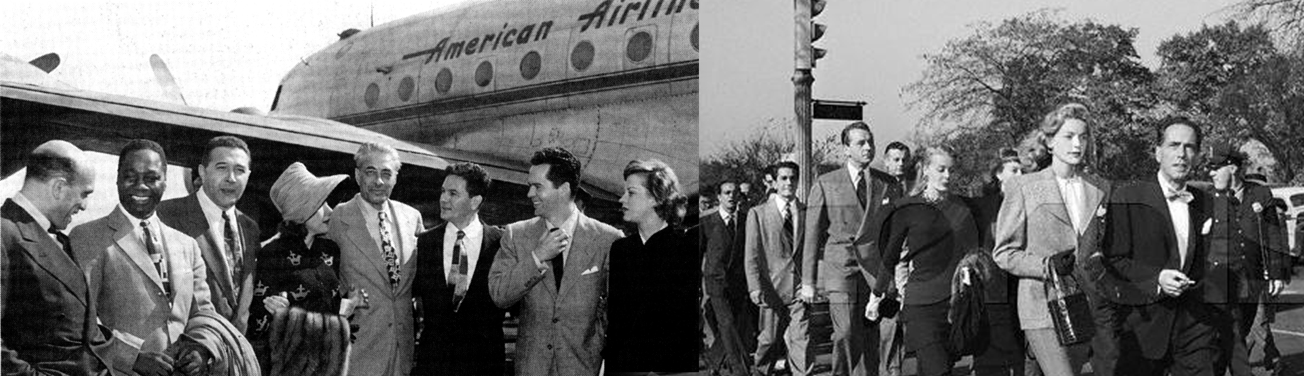

In 1947, a star-studded group of celebrities from both the East and West coasts, including Humphrey Bogart, Lauren Becall and John Garfield, flew to Washington D. C. to raise their collective voices in opposition to the first of many HUAC investigations. Among those who protested (above), Canada Lee was the only African-American in attendance. Less than four months later, Lee himself would become a target. Unable to find work, his health began to suffer greatly.
2: WHAT MAKES A LEADER?
By 1943, Canada Lee was ‘the greatest actor of his time’ according to legendary theater critic Brooks Atkinson. In 1945, Ed Sullivan trumpeted him as being the leading black figure in entertainment. Even FBI Director J. Edgar Hoover singled him out as a man of prominence in personal letters to the Department of Justice. His stage and screen work depicted blacks with dignity unlike any other before him. Lee came of age in the Federal Theater Project. Out of all the great black performers to come out of the Negro Theater, among them Poitier and Robeson, Ossie Davis, Earle Hyman, Ethel Waters, Ruby Dee, et al., only one among them, Canada Lee, was the former Negro Welterweight Champion of the World. Lee was a fighter, and when stardom was thrust upon him over night, he determined to use his fame to conduct a full frontal assault on the moral stain of racism in America. The fight cost him his life, good name and legacy… until now.
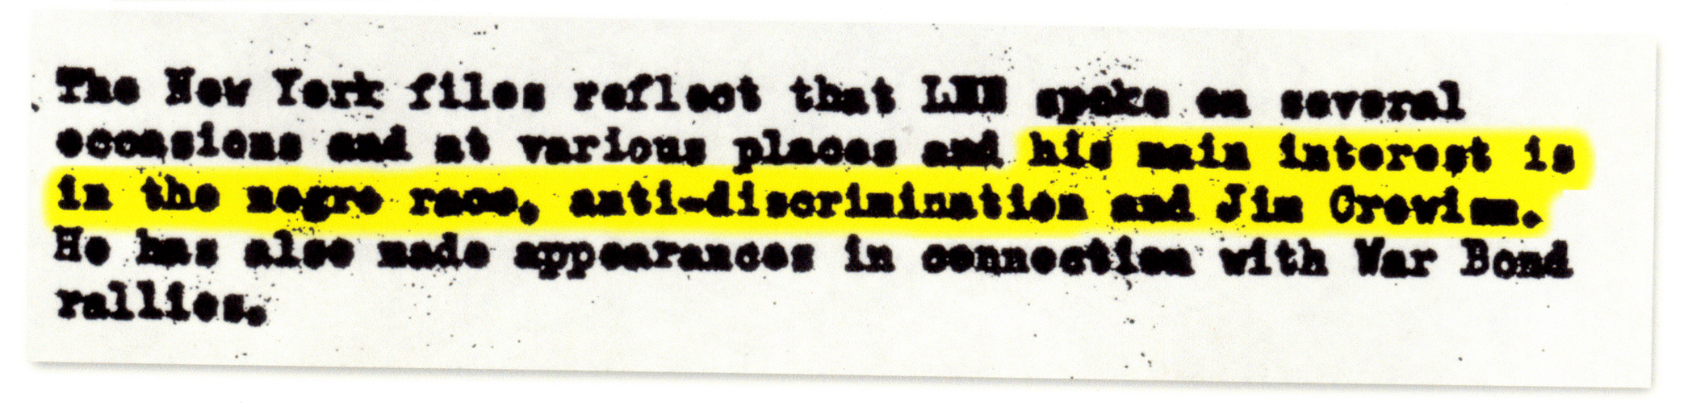

Previously redacted excerpt from Lee’s FBI file. Lee was investigated for sedition, but never charged with a crime.

3: WHO DECIDES WHAT IS PATRIOTIC?
Canada Lee had been knocked down a number of times in his life, one of which left him blind in one eye. Unemployed, broke and permanently injured, Canada Lee literally stumbled into an audition at the Harlem Y.M.C.A. in 1934 and landed a new career, acting. By 1945, Lee’s voice rang out like no other before him every time he stepped up to the microphone, as radio host, as public speaker and as performer. What makes him so unique?
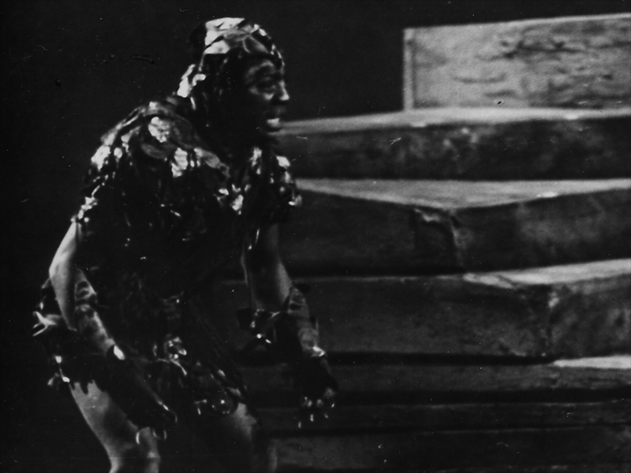
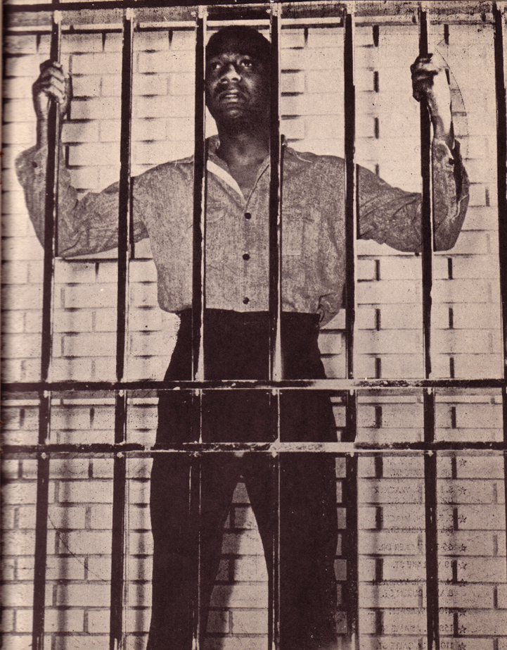
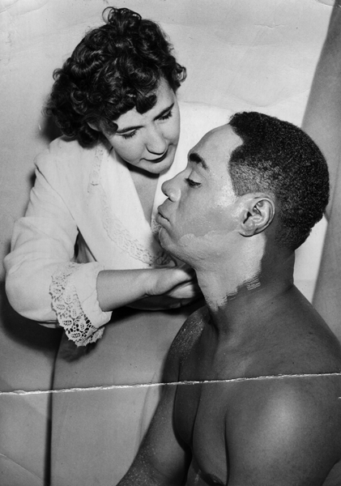
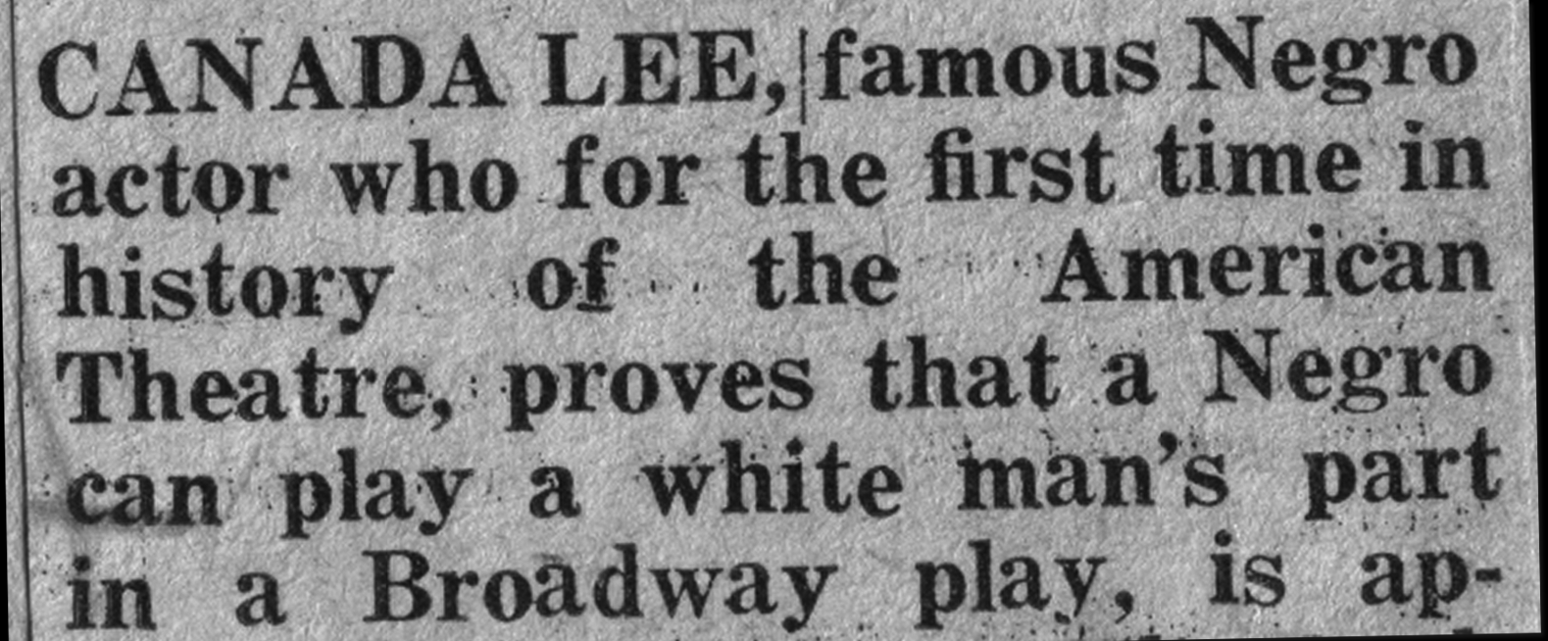
Canada Lee did not denigrate his or any other black person’s dignity. He performed with eloquence, artistry and soul. From his landmark performance as the first black to perform Caliban in Shakespeare’s The Tempest on Broadway, to what actor Earle Hyman described as “a smoldering power on stage,” no black man had previously had the opportunities Lee did. Before Paul Robeson’s Othello, well before Sydney Poitier’s Oscar, Canada Lee was a household name. Canada Lee stood alongside Paul Robeson, both black titans in a predominantly white entertainment world. His performances were depictions of the grace and dignity inherent to a race on the verge of overcoming centuries of enslavement. Canada lived among Harlem’s royalty in the years following its Renaissance. He was a close friend with greats like Lena Horne, Duke Ellington and Adam Clayton Powell, Jr. - even sparring partner to an up and coming Joe Louis. He was well liked and respected throughout town and though the star of Broadway for a number of years, he, like every other black in America, could not get a bite to eat on the ‘Great White Way.’

Lee in Native Son, The Tempest and Duchess of Malfi - 1945, two years after Robeson’s Othello, Lee plays in whiteface.

I am very happy to be here and I deem it quite a – I was going to say I deem it quite a privilege to be here but it’s not a privilege, it’s a duty to come here this evening. I am a Negro and a proud Negro. A Negro who intends to fight to the death for the rights of my people. *
Mass demonstration Chicago, IL
Sunday, Oct. 7th, 1945
Lee collaborated with Orson Wells, was sought by Alfred Hitchcock, worked with Eugene O’Neill, Lee Strasburg and Stella Adler, was close friends with Charlie Chaplin and Langston Hughes, even inspired a young Neil Simon to take an interest in theater. Canada Lee was an indomitable presence in both the black and white social circles during the 1940s and 50s. With his uncompromising stance on progressive issues and unquenchable voice, he became a power on the national stage. Tragically, at the height of his career, Lee’s uncompromising stance on civil rights prompted the U.S. Government to defame his reputation and destroy his career. Lee died in 1952 at the age of 45, penniless and all but forgotten. Over fifty years later, CANADA LEE - MAN OUT FRONT gathers an unprecedented cast of people to reclaim the legacy of a great performer, patriot and pioneer.
PRODUCTION BIOs:
Kenneth Kilfara Producer / Director
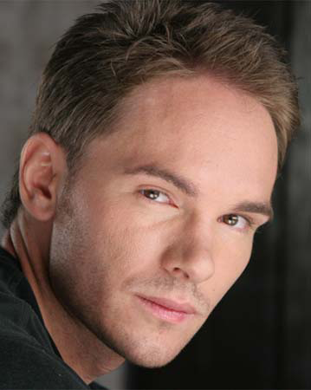

Kenneth Kilfara is an award-winning filmmaker who has screened across the U.S., Canada, Bermuda, and Germany, was one of the youngest full-time faculty members in the history of University of Georgia. He has guest-lectured in Germany and the United States, in both classrooms and private venues. With extensive experience in both large-scale and one-on-one environments, Kilfara wears many hats: teacher, performer, editor and also freelance website designer. At UGA, he produced and co-wrote an interactive multi-media performance piece for a cast of 12 that performed in Chicago’s prestigious Second City. Kilfara is also a professional swordsman; his credits include History Channel’s The Last Stand of the 300 and a member of Swordplay L.A. He currently teaches Media Studies at the Ross School in East Hampton, NY, where he, along with three other faculty members, chaperoned a two-week-long trip to Morocco with twenty-four students. Kilfara sits on the Board of Trustees for the newly reconstituted Canada Lee Heritage Foundation, is a founding member of the Athens Film Foundation and co-owner of the online video game company Insight Interactive Games.
EDUCATION
MFA in Dramatic Media University of Georgia 2004
Magna Cum Laude
BA in Drama University of Georgia 2001

FILMOGRAPHY
Iran – Descent into Madness Documentary work in progress 2009
Canada Lee – Man Out Front Director/Producer, Motion Factory Films 2003-09
After We Had to Leave Director/Producer, Motion Factory Films 2007
On Assignment Producer, University of Georgia 2004
The End Runner AD/Star, Motion Factory Films 2002-03
Before Crossing Director/Producer, Motion Factory Films 2002
The Right Copy Director/Producer, Motion Factory Films 2002
7 Untitled 8 mm Shorts Director/Producer, University of Georgia 2002
PROFESSIONAL EXPERIENCE
Project Kashmir Website and Poster Designer, Hollywood, CA 2008
CBS’s Rules of the Game Assistant Editor Burbank, CA 2008
Juma TV Assistant Editor, Burbank, CA 2008
Visions Made Real, Inc. Editor, Hollywood, CA 2007
Tidal Wave Media, Inc. Editor, Hollywood, CA 2007
J&M Costumers Web Designer/Editor, Hollywood, CA 2007
Eo Studios Editor/DVD Author/Motion Graphics Artist, Athens, GA 2006
PODz (online game) Production Manager, Programmer 2005
Center for Humanities & Arts Special Guest Lecturer, Athens, GA 2006
Humboldt University Special Guest Lecturer, Berlin, Germany 2005
Word Whacky (online game) Production Manager, Programmer 2005
Georgia Museum of Art Lecturer, Athens, GA 2005
The Ticket Producer, Second City, Chicago 2005
13th Cinema of Tomorrow Special Guest Lecturer, Augsburg, Germany 2003
(professional acting resume available at www.Kilfara.com)
ACADEMIC EXPERIENCE
Teenage Techie Producer, The Ross School 2008-09
Finding High School Producer, The Ross School 2008-09
Video Production Electives
9th & 11th grade Media Studies The Ross School 2008-09
Fictional & Documentary Instructor University of Georgia 2004-05
Filmmaking/Interactive-Narrative

WEBSITES:
www.Kilfara.com www.BlacklistTheMovie.com
www.ProjectKashmir.org www.JMCostumers.com

REFERENCES
Allen Partridge..………………………………(724) 357-3781, allen.partridge@iup.edu
J. Michael Hussey………………………………………(706) 255-3382, mike@uga.edu
Senain Kheshgi………………………………(323) 243-9683, senain@dishoompix.com
Dini Zimmerman……………………………………

KEY PERSONNEL:
Tim Nackashi Editor / Associate Producer / Camera Operator
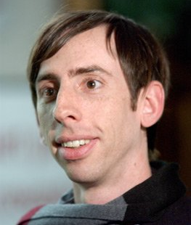

Award-winning filmmaker who collaborated with actor/producer Edward Norton and co-director David Sampliner on the award-winning documentary Dirty Work which premiered at Sundance 2004, broadcast on the Sundance Channel and screened at Silverdocs, Full-frame, Calgary Int’l and won Best Documentary Feature at the 2004 Atlanta Film Festival and Jury Prize at Bendfilm 2004.

FILMOGRAPHY
Radiohead: The Making of House of Cards Producer 2008
Stuntmen Editor 2008
Obama Field Producer, Camera 2008
Wired Science Editor 2007
Sold In America Editor, Composer 2007
Cop Car Confessions Editor 2007
The Paper (Feature Doc) Composer 2006
Project Kashmir (Feature Doc) Camera, Editor 2006
Cleft Director, Camera, Editor 2006
Tattoo Diaries (TV Pilot) Director, Camera 2005
Dirty Work (Feature Doc) Co-Director, Camera, Editor 2004
R.E.M.-A Year In the Press Editor, Sound Design 2004-06
A Life of Choices (Short Doc) Editor 2004
PROFESSIONAL EXPERIENCE
Eo Studios, Athens, GA Co-Founder, Production Manager 1999-2004
EDUCATION
Post Baccalaureate Studies in CGI The University of Georgia 1999
BFA in Visual Arts The University of Florida 1995
REFERENCES
Kate Amend (323) 578-5700, kamend@sbcglobal.net

JIM VIRGA Cinematographer / Consulting Producer


El Charango – Director, short, Spanish-language documentary, recently screened at the 2006 Silverdocs Film Festival Director –Dancing on Mother Earth, winner, Eastman Kodak Documentary Award, Indian Diaspora Film Festival in New York and screened at the Smithsonian Native American Film and Video Festival in addition to numerous film festivals nationally and internationally. Mother Earth was broadcast on PBS in November 2003 in more than 40 cities across the United States.
As a professional photojournalist, Virga’s work has been published by dozens of newspapers and magazines throughout the country and abroad. During his 10 years as a staffer at Ft. Lauderdale’s Sun-Sentinel newspaper Virga covered stories in Cuba, Haiti and Central America. He has won several National Press Photographer Awards, and his photos have appeared in the Best of Photojournalism Books.

OUR ADVISORS:
FILM ADVISORS:
- Peter Miller (Producer of ITVS-funded in-progress A Class Apart, producer for Ken Burns, including Jazz, Frank Lloyd Wright, producer, Academy Award-winning, American Dream)
- Senain Kheshgi (Director of the ITVS-funded documentary Project Kashmir)
- Dini Zimmerman (CNN director of programming, Producer, etc.)

HISTORICAL ADVISORS:
- Tula Goenka (Producer, Almost Famous, first assistant editor, Malcolm X, assistant editor, Do The Right Thing, Salaam Bombay!, Mississippi Masala)
- Valerie Boyd (Author, Wrapped in Rainbows: The Life of Zora Neale Hurston, 2003 Georgia Author of the Year, former arts editor, The Atlanta Journal-Constitution)

NON PROFIT FISCAL SPONSOR:
Documentary Educational Resources, (www.der.org)

AUDIENCE:
The film is being produced for national public broadcast, with ancillary markets including but not limited to release on DVD and online download for home viewing. We anticipate a strong demand for CANADA LEE – MAN OUT FRONT in light of its historical relevance, current themes, and dramatic unearthing of Lee’s legacy, which has been all-but forgotten for over half a century. The combination of genuine human tragedy within the historical context of a griping time in America’s socio-political history should resonate with a number of viewing audiences.

Our primary viewership includes: African-Americans (youths in particular) and individuals who are captivated by early American political, entertainment and even sports history. CANADA LEE – MAN OUT FRONT is also essential viewing for a secondary audience: those who wish to learn more about the history of radical ideology in America. By presenting a complex and intimate examination of the limitations faced by African Americans during the anti-black, anti-communist backlash in America prior to World War II, this film is intended to initiate a public dialogue among several tertiary audiences as well, including: local advocacy groups, schools and a variety of youth groups.

OUTREACH:
This documentary also makes a tangible link between the protection of civil liberties and the presence of truthful images in the media. Lee’s life personifies this connection, and his story speaks to the empowerment of marginalized groups. The outreach campaign will build towards the goal of engaging the public at large and expanding civic dialogue. A website will be designed initially to promote the film, but over time, it will evolve into a long-term repository and research tool. Teachers will find this a useful tool to incorporate into lesson preps. To maintain a long-term presence in these communities, additional grants and sponsorship will be sought to fund a screening and public speaking tour.

To date, filmmaker Kenneth Kilfara has already spoken about Canada Lee at numerous venues, including Humboldt University in Berlin, Emory University, the University of Oregon, the Georgia Museum of Art and the Center for Humanities and Arts. Interviews have been conducted with various print and online sources. The producers intend to partner with TV stations and advocacy organizations that are interested in increasing public awareness about issues of race through community forums. For the film’s research component, the production has built a relationship with The Schomberg Center for Research in Black Culture, the premiere library for African American studies, and intend to create some form of permanent interactive display.

WITH SUPPORT FROM:
- The Canada Lee Estate
- The Canada Lee Heritage Foundation
- The Schomburg Center for Research in Black Culture

CURRENTLY BUILDING PARTNERSHIPS WITH:
  - The National Black Programming Consortium
  - The Screen Actor’s Guild Foundation
  - The Duke University Center for Documentary Studies
  - MediaRights
  - The Paul Robeson Estate Foundation
  - Teaching Tolerance, The Southern Poverty Law Center
- The Institute for Diversity in the Arts at Stanford University
- California Newsreel
- Working Films
- American Library Association
- American Federation of Television and Radio Artists
- Creative Response to Conflict

PROJECT STATUS:
2003: Met and befriended Frances Lee Pearson and agreed to begin interviewing.
2004: Interviewed and sat with Frances numerous times, flew with Frances to New York and assisted
her with conducting research at the Schomburg Center for Research in Black Culture, met with producer Peter Miller, who agreed to sign on as project advisor, interviewed James Hatch, Earle Hyman and Oscar Brand, met with close friends of Canada, Dr. Jack Geiger and Leslie Nash, spoke and presented research findings at numerous University of Georgia symposiums and the Georgia Museum of Art.
2005: Conducted additional research at the Schomburg. Digitized and donated as a gift, most of the
Canada Lee Photo archive, presented at Independent Film Week in NYC sponsored by IFP, spoke in Berlin at Humboldt University, appointed to the Board of Trustees of the Canada Lee
Heritage Foundation and secured exclusive documentary rights to Lee’s life story.
2006: Spoke at the Athens Film Foundation, University of Oregon and Emory University, spoke
and presented a video tribute at France Lee Pearson’s memorial, accepted an award on behalf of Canada Lee from the National Black Herstory Taskforce and conducted research at the Museum of the City of New York.
2007: Flew to Philadelphia and interviewed Leslie Nash, was interviewed by Film Threat Magazine,
presented to both the NYC and LA Doculink 10x10 filmmakers forums, interviewed historians Ed Guerrero and Howard Zinn, helped update the Canada Lee Heritage Foundation charter.
2008: Received grants from the Pacific Pioneer Fund and the Yip Harburg Foundation, conducted
further research into the House Un-American Activities Committee and interviewed historian Glenda Gill.
2009: Interviewed by the East Hampton Star, began redesigning www.CanadaLee.org, presented
project to former CNN producer Dini Zimmerman and filmmaker Senain Keshgi – both agreed to sign on as project advisors. Received a grant from the Jean-Claude Baker Foundation.

* It is our intent to cast reputable actors to read excerpts Lee’s speeches aloud, from a list including: Morgan Freeman, James Earle Jones, Denzel Washington, Danny Glover, Forest Whitaker, et al.

